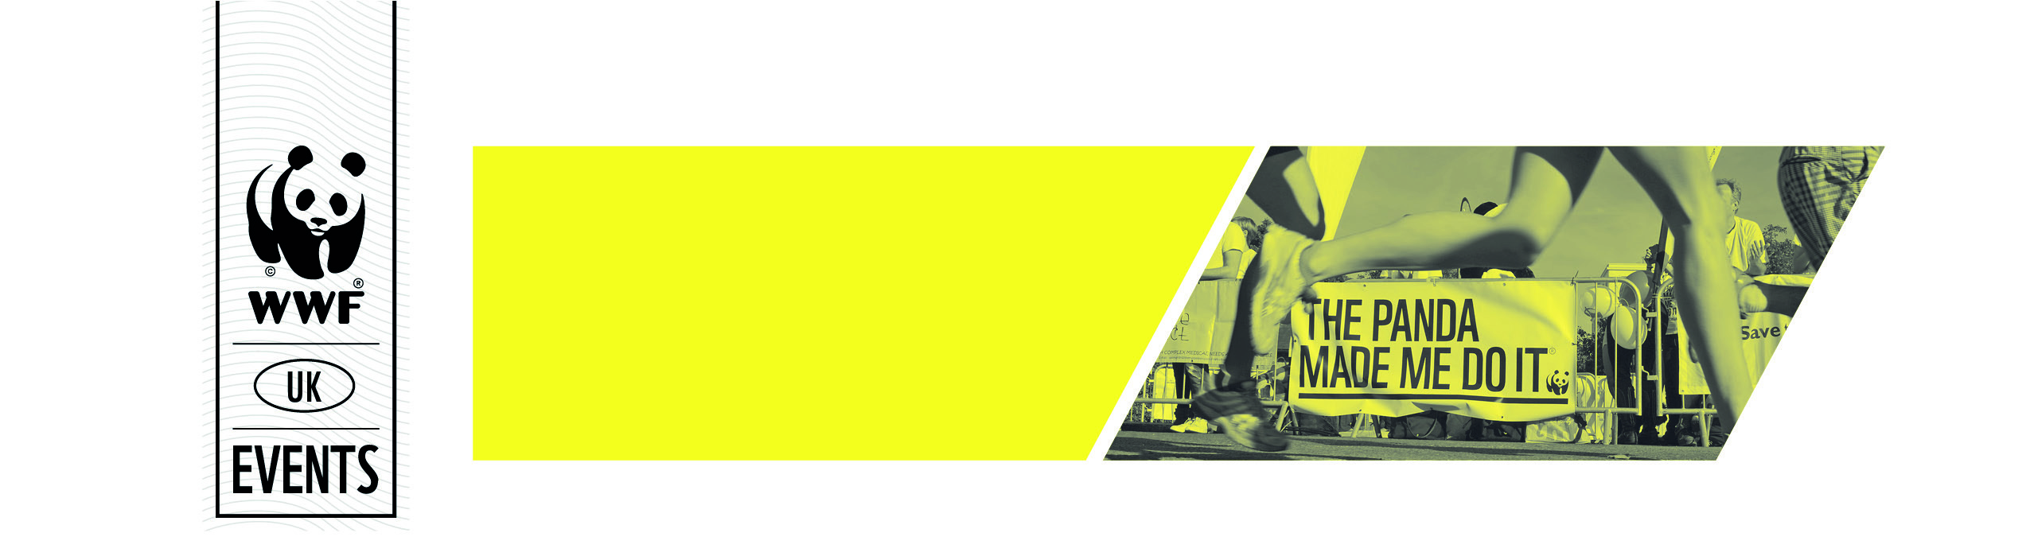
Read all about it… The Panda Made Me Do It!
A great way to tell more people about your challenge is by getting some press coverage. This will help boost your fundraising and spread the word about WWF’s work. Here is a step by step guide on getting your story into the papers!

Why will they choose me?
You need to think why your story is different, so; original, daring, emotive or even quirky. Whilst not everyone can run a marathon barefoot, this unique element for one of our runners saw him being interviewed by the BBC nationals and covered in his local newspaper. Think about your life story moments that can capture a local newspaper’s interest. Are you known in your area? Have you fundraised thousands before? Have you been through a gruelling illness and want to inspire others? Is the marathon one of 10-20 events you’re doing for the year? Do you have an interesting and rare job?
Have a think about what will make you stand out.

Where DOES YOUR SUPPORTERS’ money go?
Putting donations into context can often encourage people to donate so why not include some of these facts:
£5 could buy food for a ranger for a day’s monitoring in the field – rangers work very long hours and are often out in the field overnight when working in remote locations.
£10 could buy three metres of stone buffalo wall built by community rangers to prevent human-wildlife conflict
£25 could buy 80 tree seedlings to be grown from seed in a nursery and then be distributed for planting in critical areas of tiger habitat where the forest has been heavily degraded.

Who should I contact?
Depending on where you live, contact your local newspaper, community magazines or even research professional trade publications. For example if you’re a vet, don’t be afraid to contact ‘Vets on-line’ if you feel comfortable approaching them. Publications need copy, so will appreciate warm, amusing, personable stories.

How do I do it?
A short concise account of who you are, where you’re from, what you’re doing, when and who for will tell an editor very quickly and clearly about your run. Short quotes from yourself and an explanation of your passions and motivations will add more to the story, but don’t ramble on!
When referencing WWF
in your story please avoid using “World Wildlife Fund” and try to mention we are the world’s leading conservation charity!

What else?
A clear photograph of you in your running/cycling/ fundraising outfit (!) will help. An editor likes text and a nice image but ensure you took the photograph and it was not taken by a third party such as a professional or race photographer, to avoid a breach of copyright.
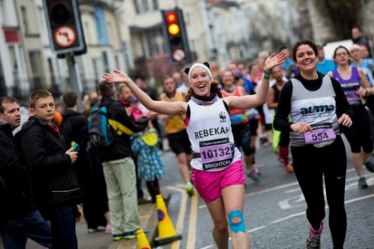
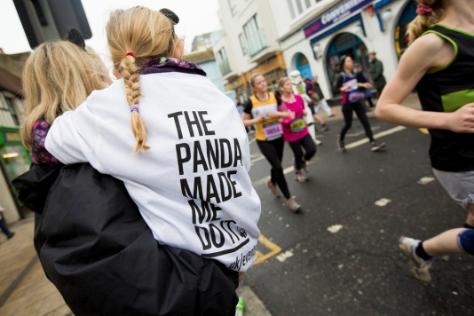
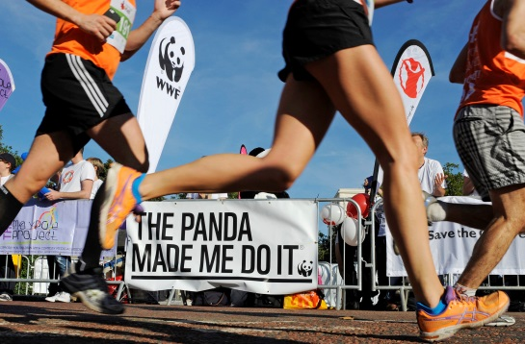
Thank you so much for supporting WWF and helping save our beautiful planet.

